**Equity and Continuous Improvement Summer Planning Session**

# **Today’s Agenda**

* 25 mins --- Introductions and Overview of the Work
* 20 mins --- Developing Goals
* 30 mins --- Developing a Theory of Action
* 15 mins --- Wrap-Up and Next Steps

# **Introductions and Overview (25 Minutes)**

**Pre-Work Notice/Reflect Prompts:**

* Who am I as a leader in this space?
* How am I showing up for the students I am responsible for?
* How may I intentionally/unintentionally get in the way of their progress?
* What role do my intersectional identities play in my decision-making process?

**Icebreaker (Share one thought you have from the pre-work, Answer 1 icebreaker below)**

* What have you read/watched/listened to recently and enjoyed?
* What is one word that you would use to describe yourself as a leader or learner? Why?
* What's something you know about yourself that you think others tend to miss?
* What is something about you that others can’t tell just by looking at you?
* What does equity mean to you in your work and/or life?

**Draft Norms**

* Be Present
* Action items are always reviewed.
* Discussions are based on the data as a common starting point.
* Be vulnerable (we’re all learning)
* Stay curious (keep a learning/inquiry stance)
* Accept and expect non-closure
* Remember who is not in the room
* Recognize how your own social positionality (e.g., race, class, gender, sexuality, ability) informs your perspectives and reactions
* Use the data as a flashlight, not a hammer!

|  |
| --- |
| Are there any norms you would like to add or change? |

**Roles**

* Continuous Improvement Team will co-facilitate monthly meetings designed to examine equity centered data trends to develop targeted and actionable next steps. As part of this process, CI team members will provide coaching on data collection, analysis, and facilitation techniques to empower school personnel to make data informed decisions.
* Equity Office will serve as lead content experts for how to have courageous conversations about race, barriers to equity, and developing an adult growth mindset that puts students at the center of this work.
* School Teamswill analyze data and school trends to determine root cause and find actionable steps to solutions. School teams will implement strategies, track/record their findings, and engage in discussion on progress with the CI Team monthly. The Continuous Improvement team will gradually release responsibilities to the school team over the course of the 2022-23 school year.
* CI Champions: Each school will identify up to two CI Champions who will receive monthly training and gradually assume facilitation/data analysis responsibilities for this work

**Overview of the Continuous Improvement Process**

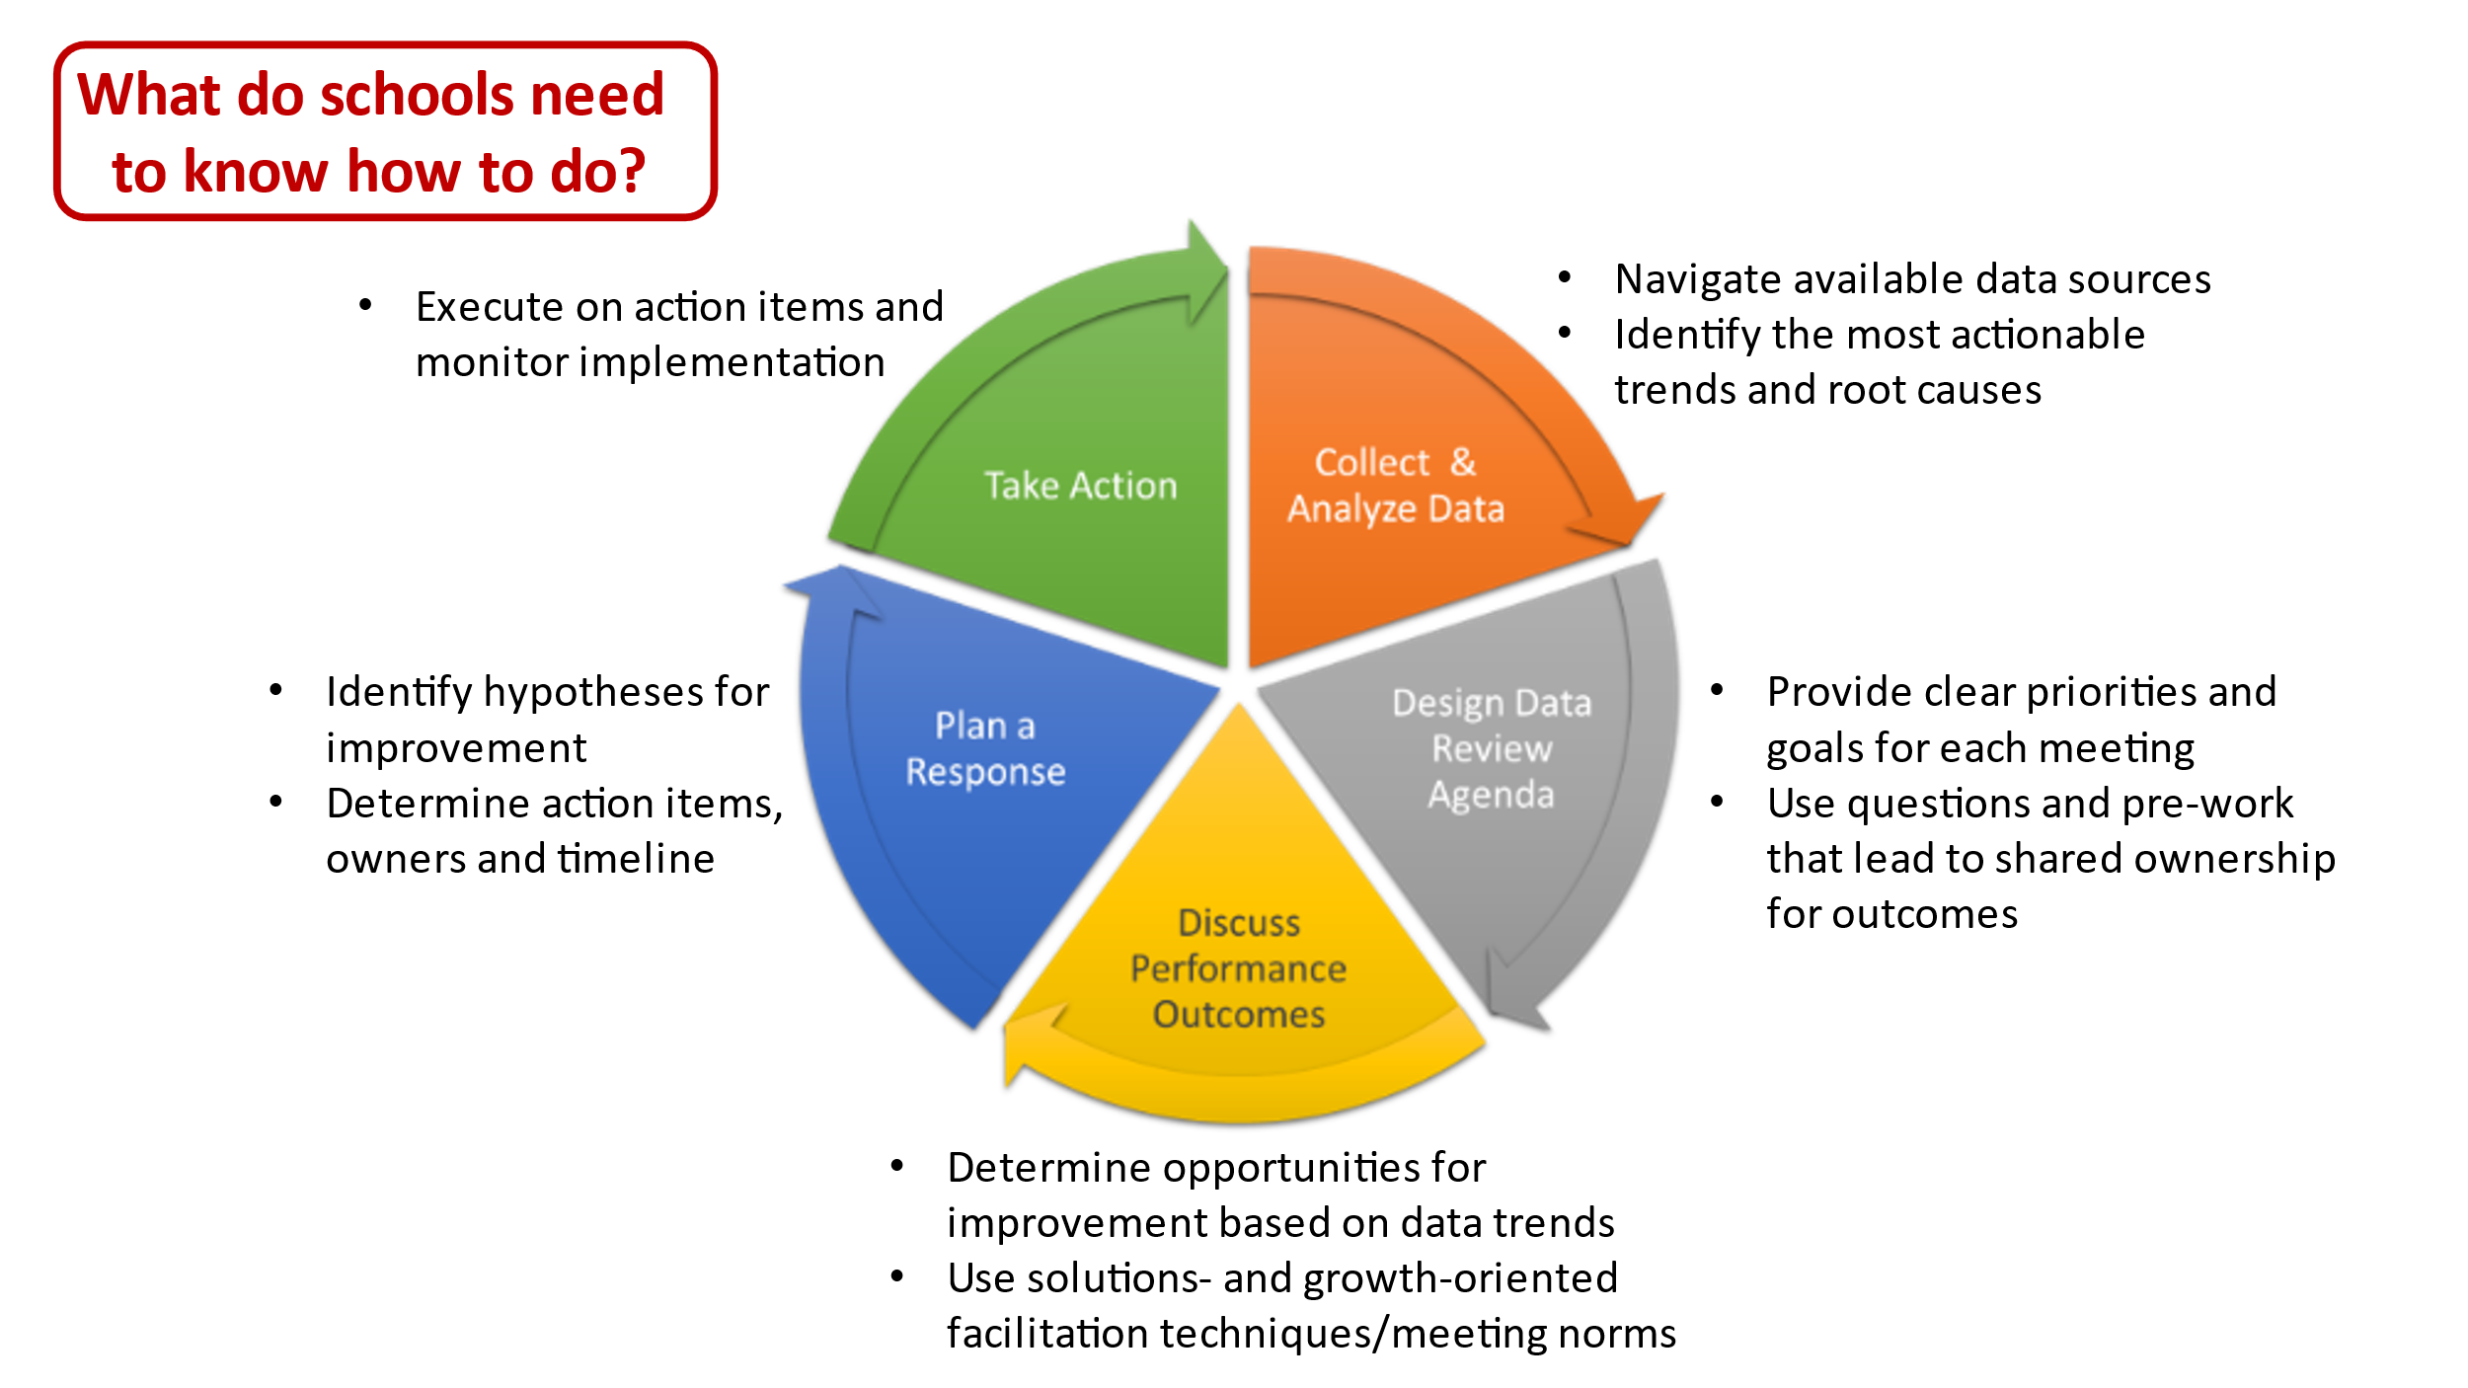

**What is CI?**

* Continuous Improvement is a process by which we test and track effectiveness of strategies. Think of the process as 1) seeing the gaps that exist 2) thinking of ways to improve them 3) testing and tracking strategies to see if they improved the problem. We back this up with data so we can prove to others what we have done works.

**Why we are here:**

* Our 2 main objectives are: 1) to design and implement equity-centered CI practices **and** 2) to identify/scale up best practices from schools to increase adoption of CI district-wide.
* We are defining education equity as “Removing the predictability of success or failure based on race, proficiency in the dominant language, gender, class, ableism etc. Beyond the predictability of success or failure, educational equity means that every child is seen for who they truly are, and their unique interests and gifts are surfaced and cultivated.”

# **Developing Goals (20 Minutes)**

Prepare this section in advance with specific 22-23 data for the school you are meeting with– some examples of data/trends are below.

**Course Failures (9th Grade)**

Q1



Q2



Q3



Q4



Courses with the highest failure rate (9th Grade)



**Chronic Absenteeism**



**Panorama Student Survey**

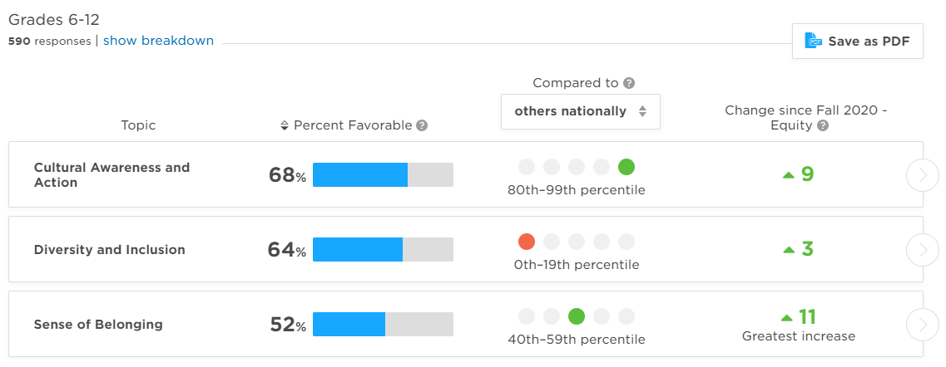

**Draft Goals** – Brainstorm potential goals and then determine what one goal is the most important one for the school to achieve using data/continuous improvement. Discuss which student demographic groups you want to focus on to improve equitable outcomes.

|  |
| --- |
| **Notes/Ideas on Goals and Student Groups to Focus on** |
|  |

# Developing a Theory of Action

**Root Cause Discussion (15 Minutes)**

* Based on our data analysis, what do we think are some possible root causes of this data?
* What teacher behavior (good, bad, neutral) may be leading to student outcomes?
* What leadership behaviors (good, bad, neutral) may be leading to student outcomes?
* What overall mindset shifts need to happen in order to improve student outcomes?
* What societal/external circumstances may be leading to student outcomes?

|  |  |
| --- | --- |
| **Draft Goal:** |  |
| **Teacher Behaviors That Influence These Outcomes:** |  |
| **Leader Behaviors That Influence These Outcomes:** |  |
| **What Mindset Shifts are Needed to Improve?** |  |
| **What Outside Circumstances Do We Need to Keep in Mind?** |  |

**Prototype Discussion (15 Minutes)**

What is one key strategy you want your school to implement this year to achieve the goal identified? Strategies work best when:

* They are already aligned to the school’s priorities/plans (ex: School Improvement Plan, 90-day plan, program with clear staff ownership)
* There’s data to monitor student outcomes and strategy implementation throughout the year
* There’s a clear, direct link to student experiences/teaching and learning when implemented well

|  |  |
| --- | --- |
| **Strategy of Focus:** | |
| **What priorities does the strategy align to?** |  |
| **What types of data are available for monitoring?** |  |
| **How will student experiences improve as a result of the strategy?** |  |

# Wrap-Up and Next Steps (15 Minutes):

**School Next Steps:**

|  |  |  |
| --- | --- | --- |
| **Action Item:** | **Who?** | **By When?** |
| Send me (CI Staff) a recurring time/date for our monthly data review sessions |  | 8/12/22 |
| Send me (CI Staff) the name of the 1-2 staff you would like to serve as CI Champion for your school |  | 8/5/22 |
|  |  |  |
|  |  |  |
|  |  |  |

**CI/District Team Next Steps:**

|  |  |  |
| --- | --- | --- |
| **Action Item:** | **Who?** | **By When?** |
| Set up a follow-up meeting (if needed) to complete the rest of our kick-off discussion and planning |  |  |
| Set up our tracking tool for the year with our goal, strategy, data monitoring plans and milestones (MAYA Tool) |  |  |
|  |  |  |
|  |  |  |
|  |  |  |